Collaborative Design and Implementation of
a large University's Web-based Course
Chong Ho Yu, Ph.D., Angel-Jannasch-Pennell, Ph.D., Samuel A. DiGangi, Ph.D.,
and Ruvi Wijesuriya
Instruction and Research Support, Arizona State University

Abstract

This paper discusses issues relating to the design, development, and delivery processes of multimedia modules such as Macromedia Flash®, Shockwave movies®, and Quicktime movies®. These modules were employed to teach an undergraduate plant biology class at a large southwest university. Each medium has different strengths and weaknesses. Their proper use resulted from the collaboration among the content experts, instructional designers, and multimedia developers.

Equipped with modern web technologies, instructional designers have abundant resources to deliver courses based in a multimedia and rich with interactivity. However, design is only one of several crucial factors of a successful web-based course. No matter how rich the media features are, obstacles during implementation hinder students from effective learning. For example, faculty without experience in multimedia development and distance education may under-estimate the required cost and resources, which may result in a delay of delivery and frustration. In addition, inexperienced Web developers might not realize the diversity of user computers. Web pages look good in a particular platform, a particular browser, and a particular setting might look different in other computers. Further, digital movie is said to be a useful illustration tool, however, lack of appropriate plug-ins and bandwidth may make the media unusable. VanHorn (2000) realized that bandwidth limitation would worsen the digital divide. Unfortunately, Web-based multimedia developers might not be aware of this limitation. In light of these potential obstacles, this paper discusses how a major university designed, developed and delivered a feature-rich web-based course for plant biology. It was found that in this case the design and delivery processes were more problematic than development. Solutions derived from our experience are suggested.

Course Objectives

Plant biology 108 fulfills the Natural Science General Studies Course Requirements (S1 & S2). In keeping with the criteria of S1/S2 courses, the following are objectives for Concepts in Plant Biology
1. To provide a substantial introduction to the fundamental behavior of matter and energy as it relates to plants and to the plants’ role in the biosphere.
2. To introduce the students to the scientific method and to have them gain experience with application of the scientific method to botanical problems. It is hoped that with such experiences the student will be able to use the concept of the scientific method for solving problems in everyday life.
3. To gain an appreciation and understanding of how plants work so that they may be manipulated to help solve such world problems as hunger, pollution, and global warming.
In order to fulfill the preceding objectives, use of multimedia animation were considered because several concepts in biology are process-based; it is more instructionally beneficial to illustrate those concepts in animation than plain text. The implementation of this multimedia web-based course was divided into three stages: Design, development, and delivery (see Figure 1). In the design stage, the focus centered around curriculum design, content development, and media acquisition. Instructors, including faculty and graduate assistants of plant biology, served as the content experts. Based on their input, instructional designers suggested the appropriate media. In the development stage, a positive feedback loop was established among faculty, instructional designers, and multimedia developers. Since the Web content could not updated easily, in the delivery stage a formative evaluation scheme was implemented. Students were encouraged to give comments and to report bugs to faculty, graduate assistants, and technical support personnel. The feedback was re-directed to the instructional designers and multimedia developers for corrections and enhancements of the courseware. Each stage will be discussed in detail in the next section.

Figure 1. Stages of design, development, and delivery.

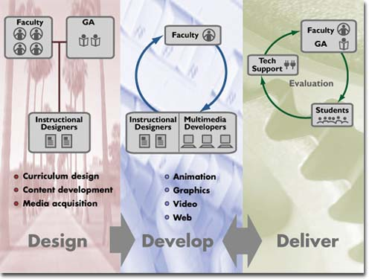

Allocation of both human and material resources is crucial to the development of a Web-based class. Besides specifying the task involved in each stage, the team also estimated the workload of each group in each stage (see Figure 2). This estimation set a reasonable expectation on each team member to ensure a smooth collaboration.

Figure 2. Resource allocation

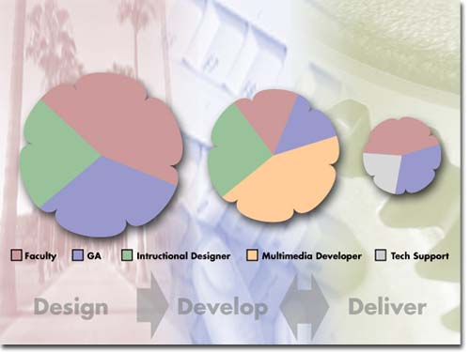

Design

PLB108 is a collaborative project between the Biology department and Instruction Support group. Faculty and graduate assistants in the Plant Biology department served as the content experts. Staff in Instruction Support served as instructional designers and multimedia developers (design team). The design team advised and assisted with course design, interface design, and storyboarding. The faculty worked closely with the Instructional designers to take ideas for concepts and convert them into a manner that best utilizes the multimedia delivery system. Based on the input from the content experts, the design team identified three media for serving different purposes, namely, MacroMedia Flash (MacroMedia, 2000a), Director shockwave (MacroMedia, 2000b), and QuickTime (Apple, Inc,.2000). Their capabilities, liabilities, and proper applications are described below:

Flash

Flash can use vector-based graphics and therefore its file size is much smaller. Unlike bitmapped graphics that are composed of pixels, vector-based graphics define the composition of an image by algorithms. A typical animated module made in Flash is as small as 10K.
Another advantage of vector graphics is their scalability. Keeping the appearance of a Web page consistent is a challenge to Webmaster because monitor size, resolution, and browser size vary from computer to computer. Vector-based graphics answer this challenge. No matter what the monitor size and the resolution are, vector-based graphics are displayed at a pre-specified percentage, and they will resize themselves according to the browser size.
As mentioned before, consistency and bandwidth limitation are considered major hindrances from course delivery. Vector-based graphics are definitely one of the ideal media for the Web.
However, vector-based graphs carry less information than their bitmapped counterparts. Therefore, they are best-suited for drawing-based images rather than photo-realistic images. It doesn't mean that Flash cannot import pixel-based graphics for photo-realistic illustration, but including bitmapped images will definitely inflate the file size. Moreover, Flash lacks the interactive features and programming capabilities as that of Director.
In the course, Flash is primarily used for modularized presentations. When a complex process is presented, a continuous and linear animation such as QuickTime may cause confusion among learners. An interactive step-animation is designed with the logical break-down of the process. For example, the Meiosis process was broken down into three steps. In each step, the animation is co-presented with descriptive text. The learner has the freedom to replay a particular step of animation (Figure 3).

Figure 3. Meiosis process presented in Flash

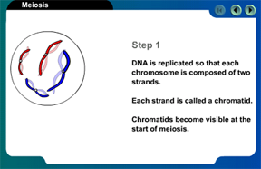

This approach is also useful to illustrate complex structure. In the Flash module displaying a flower structure, different components are showed in different steps, but the transition between steps overlay translucent components so that students understand how different parts of a flower are related to each other. In addition, Flash can also be used to associate geographical regions with biomes, which are worldwide groups of similar ecosystems that can be defined by their major vegetation type. In a Flash module, the user can click on several hot spots of a map to zoom in the region and photos of the region will be revealed (see Figure 4). Without an interactive module, the student may find it difficult to go back and forth between a map and photos.

Figure 4. Map of biomes

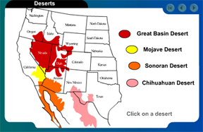

Shockwave

Shockwave is made by Macromedia Director, a multimedia authoring system with a powerful programming language, Lingo. Therefore, complicated modules such as highly interactive tutorials are better created in Director. Multimedia modules may involve a time-based process (e.g. growth of a plant, environmental change), a structural relationship (e.g. cell structure), or both. Every multimedia authoring package adopts some type of analogy, which is temporal or/and spatial oriented, to display the programming environment. For example, HyperCard, HyperStudio (Knowledge Adventure, Inc., 2000), and SuperCard (IncWell, DMG, Inc., 2000), obviously, use a card analogy with an emphasis on spatial structure, in which different layers and objects represent different functions. Authorware (Macromedia, 2000c) uses a flow-chart analogy with a focus on temporal transition, in which icons "flow" along the decision tree. Director uses a movie frame and channel analogy. This programming environment incorporates both temporal (frame) and spatial (channel) dimensions. Therefore, it is considered more powerful than other authoring packages, which use either temporal only or spatial only metaphor. However, since graphics in Director are pixel-based and thus the final product, Shockwave, may be bandwidth-consuming.
In this course, shockwave is used for interactive tutorials that require user interactions. For example, in the illustration of natural selection, users are asked to drag a dark moth and a light moth to a light-colored tree. Later on, the same moths are dragged to a dark tree darkened by pollution. Before the pollution, the light moth is more likely to survive for its protective color in relation to the tree. After the pollution, the survival chances tip toward the dark moth (Figure 5). The objective of this exercise is to let learners see how environment affects natural selection. Although this concept can be illustrated by text, the camouflaging function of moth’s color is more dramatic to learners when they actively move the moths from one background to another. This drag-and-drop approach is also used for testing purposes. For example, after students learned the lesson on herbaceous stem anatomy, they were asked to identify the internal organization of a stem by dragging the text into the right position. The exercise has a built-in correcting mechanism. If the student fails to drop the text into the right place, the text will revert to the original position and thus the student has to start it over until all components are correctly identified (see Figure 6).

Figure 5. The Peppered moth presented in Shockwave

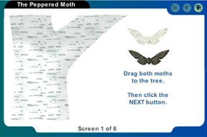

Figure 6. Stem anatomy exercise presented in Shockwave

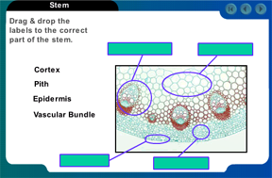

QuickTime

The strength of QuickTime is its ability to show realistic movies within a low bandwidth because certain third-party software utilities such as Media Cleaner Pro (Terran, Inc., 2000) are able to compress QuickTime files without losing viewable quality. One of the drawbacks is that QuickTime does not have many interactive features. Among the three chosen media, QuickTime is the most bandwidth-intensive.
QuickTime is a proper medium for realistic movies. For example, many biology students may not have a chance to use a high-powered electronic microscope to observe objects at the molecular level such as how a new life is formed through the fertilization of an egg by a sperm, and how the movement of a cell (see Figure 7). This web-based course includes QuickTime movies, which were converted from footage taken from microscopes. In addition, QuickTime can be used for illustrating a time-lapsed process such as the growth of a plant. The purpose of this QuickTime illustration is to explain that each organism has a finite size that it can achieve (see Figure 8).

Figure 7. Movement of a cell showed in QuickTime

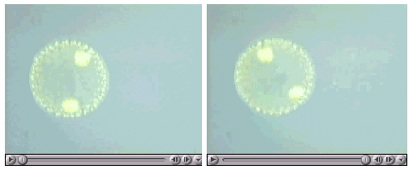

Figure 8. A growth process illustrated in QuickTime

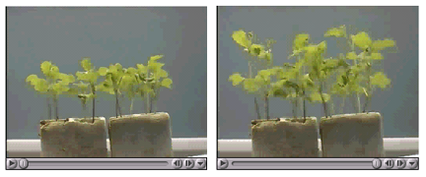

Another use of digital video is the re-creation of historical events. Reading text about history may be dry, however, dramatization of history by actors and actresses gain students’ attention. In this class, Mendel and Darwin, prominent figures in biology, come alive in digital video interview.
Software and hardware requirements were imposed on registered students. All the preceding multimedia modules were designed to run on the combination of these specific software and hardware configurations. The minimum requirements are:

- Windows 95/98/NT or Mac OS 7.5
- Multimedia Pentium or PowerPC
- 28.8 modem
- 800X600 resolution, 256 colors (8-bit)
- Netscape 4.0 or Internet Explorer 4.0 or AOL 4.0
- QuickTime Player 3.0
- Shockwave/Flash Player 7.2

The design team was aware that students might not have QuickTime or/and Shockwave/Flash plug-ins. Technical assistance to students will be discussed in the section of delivery.

Development

At the development stage, instructional designers worked with multimedia developers to convert the storyboards into multimedia and upload the course to the web. With each release, the faculty proofread the media and provided feedback and changes if necessary. To simulate a realistic learning environment for beta-testing, testers accessed the web content through a dial-up modem and viewed them in a 15-inch monitor. It was found that download time of QuickTime movies was excessive. To counteract this problem, QuickTime movies were burned into a compact disc and offered to students as an alternative. To increase the user-friendliness of the CD, a front end written in MacroMedia Director was inserted so that users could easily navigate across movies. Taking bandwidth into consideration, the development team had decided to convert QuickTime movies to QuickTime streaming and Real streaming movies in the next release. The difference between a digital movie and a digital streaming movie is that the latter can play almost immediately while more signals are being “streamed” to the destination.
The copyright issue was a major concern during the development process. Besides using royalty-free images, the development team created many drawings and diagrams. Approximately half of the development time was spent in creating original artwork for the course.

Delivery

The course was delivered through Blackboard’s CourseInfo, which has built-in features for Web-based courses such as login, quizzes, grade book, chat room, bulletin board, user access tracking, and many others. Students were required to log in, and their movement within the course website could be tracked. Tracking website traffic enables the network administrators and WebMasters to identify the "rush hours" and thus to choose a better time for updating webpages. For example, the user log (see Figure 9) clearly indicates that during lunar hours and in the evening (5-6 p.m.) the server received most hits from users.

Figure 9. Usage of Website by hour of the day

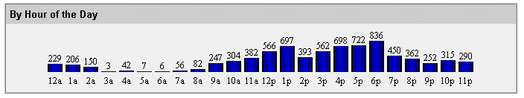

Despite that hardware and software requirements were specified prior to the course, several students were not able to fully access the course materials due to the absence of a proper Web browser and plug-ins. This was anticipated and a technical support team had stood by to provide assistance in upgrading the browser and installing plug-ins. The technical support service was accessible by both email and telephone.

Summary

Initially, the design process and development process were labor-intensive. It is important to structure the materials during the design process so that later modifications are minimal for future courses. Moreover, when the course is well-structured with rich content and media, based on the input from experienced faculty, a graduate teaching assistant is able to deliver the course seamlessly. As a result, experienced faculty can be released from teaching introductory classes and hence concentrate on research and teaching of upper division courses.
Examples of multimedia resources mentioned in this article are available at http://www.creative-wisdom.com/pub/aect2000b/. Readers are encouraged to explore the posted modules and give us feedback.

References

Apple, Inc. (2000). QuickTime 4. [On-line] Available: http://www.apple.com/quicktime/.
IncWell, DMG, Inc. (2000). SuperCard. [On-line] Available: http://www.incwell.com/SuperCard/supercard.html
Knowledge Adventure, Inc. (2000). HyperStudio . [On-line] Available: http://www.hyperstudio.com
Macromedia, Inc. (2000a). Flash 4. [On-line] Available: http://www.macromedia.com/software/flash/
Macromedia, Inc. (2000b). Macromedia Director. [On-line] Available: http://www.macromedia.com/software/director/
Macromedia, Inc. (2000c). Authorware. [On-line] Available: http://www.macromedia.com/software/authorware/
Terran, Inc., (2000). Media Cleaner Pro. [On-line] Available: http://www.terran-int.com/products/
VanHorn, R. (2000). Technology. Phi Delta Kappan, 81, 795-796.

