Proper use of APA
Chong Ho Yu

Dear students,
If you do not have the APA manual at hand, you can find numerous websites showing examples of APA references and citations. The following is an example:

http://owl.english.purdue.edu/owl/resource/560/01/

In this write-up I would like to highlight four common mistakes

No need to include the URL unless it is a DOI or link to an online journal

First, many students put down the names of the databases in the references. According to APA, "with the exception of hard-to-find books and other documents of limited circulation delivered by electronic databases, the database name is no longer a necessary element of the reference. This change is made in the interest of simplifying reference format. If you do include the database name in a reference, do not include the database URL” (the APA 2007 update).

For example, in the following it is not necessary to include the URL at the end because ProQuest can be accessed by subscription only. A reader who is NOT a member of the university cannot access the article by clicking on the URL, and therefore the link is not usable. The following is a counter-example

Biba, G., Rosiers, F. D., Theriault, M., & Villeneuve, P. (2006). Big boxes versus traditional shopping centers: Looking at households' shopping trip patterns. Journal of Real Estate Literature, 14, 175-182. Retrieved from https://search.proquest.com/docview/200003109?accountid=35812

On the contrary, a Digital Object Identifier (DOI), which is a permanent link, is tied to the publisher’s website. This universal link should be included because it is not tied to a library or a university. It is similar to a product bar code or a social security number. It will always refer to the article and help your reader easily locate the paper. The following is a good example.

Chan, H. W., Tse, S., Chung, K. F., Yu, C. H., Chung, C. K., & Lo, H. M. (2019). The effect of a brief mindfulness-based intervention on personal recovery in people with bipolar disorder: A randomized controlled trial. Biomedical Central Psychiatry, 19, 1-10. https://doi.org/10.1186/s12888-019-2242-0

Another form of URL that should be included into the reference is the link to an online journal article. As indicated in the example below, this type of URL points to the publisher’s website and the article is accessible to the public.

Yu, C. H., Lee, H. S., Lara, E., & Gan, S. G. (2018). The ensemble and model comparison approaches for big data analytics in social sciences. Practical Assessment, Research, and Evaluation, 23(17), 1-11. Retrieved from https://pareonline.net/getvn.asp?v=23&n=17

In the following example both the DOI and the link pointing to the publisher’s website are included.

Yu, C. H., Lee, H. S., Lara, E., & Gan, S. G. (2019). Adult learning across USA, Canada, and New Zealand: A cross-cultural study of PIAAC. International Education Studies, 12(5), 1-16. DOI:10.5539/ies.v12n5p1. Retrieved from http://www.ccsenet.org/journal/index.php/ies/article/view/0/39300

Journal Articles Numbered by Volume

Second, the issue number of the journal can be omitted when the page numbers are consecutive across all the issues in the same volume. Please read the following carefully:

These journals are paginated by volume. In each volume it begins with page one in Issue one, and then continue numbering in subsequent issues. For this type of journal you can omit the issue number.

Egerton, G. (2004). Entering the age of human rights: Religion, politics, and Canadian liberalism, 1945-50. Canadian Historical Review, 85, 451-479.

Journal Articles Numbered by Issue

This refers to journals in which each issue begins with page number 1. After the volume number, put a period and then the issue number. Italicize the volume number, but not the issue number.

Messud, C. (2004). Then. Kenyon Review, 26(4), 34-45.
How can you tell whether the journal is paginated by volume or by issue? The rule of thumb is: If the page numbers are very huge (e.g. 499-510), then you know that it is impossible for a single issue to carry 500 pages. It must be paginated by volume.

For more information please read:
https://owl.purdue.edu/owl/research_and_citation/apa_style/apa_formatting_and_style_guide/reference_list_articles_in_periodicals.html

Unnecessary citations

Third, some students make unnecessary citations or/and excessive direct quotations. For example,

What is known is that death is inevitable (Braun, Gordon, & Uziely, 2010; Dwyer, Deshields, & Nanna, 2012; Wardhere, 2014).
Due to the fact that immortality is not an option as of yet, death is an inevitable part of life (Braun et al., 2010; Dwyer et al., 2012; Wardhere, 2014)

Do you need to cite so many references to support the claim that death is inevitable?

Sometimes a direct quotation is not necessary. For example, Kübler-Ross “fertilized and influenced the field in distinctive ways” (Dugan, 2004, p. W24). Indeed, it is more efficient to simply rephrase the ideas of an article. The preceding quotation can be rewritten as Kübler-Ross made significant contributions to the field (Dugan, 2004).” Nonetheless, sometime a direct quotation is needed. For example,

- The original statement is very profound (e.g., “Ask not what this country can do for you. Ask what you can do for this country.”)
- The original statement is so complicated that its meaning may be distorted after paraphrasing (e.g. “Uncritical semantics is the myth of a museum in which the exhibits are meanings and the words are labels. To switch languages is to change the labels.”)
- You want to analyze the original statement or passage word by word (e.g. Bible study or hermeneutics)

It is noteworthy that your paper should comprise your own writing. References are cited to support your own ideas. If there are excessive direct quotations, then the paper is no longer “your” paper.

It is also unnecessary to cite the same references several times in the same paragraph. For example,

The learning outcomes recorded in the test were literacy, numeracy, and technology-based problem solving scores. It is important to point out that Organization for Economic and Cooperation Development (OECD) employed multiple computerized adaptive testing (MCAT) in PIAAC (OECD, 2013). In traditional computerized adaptive testing, the next question presented to the examinee depends on his/her response to the previous question. In MCAT, items are grouped into several clusters known as testlets (OECD, 2013). Similar to CAT, the next testlet seen by the examinee is dependent upon his or her performance on the previous testlet. Because not every PIAAC participant answered the same questions, OECD utilized imputation methods to estimate the scores. Uncertainty is an inherent property of any estimation and thus for every participant OECD reported ten plausible scores, known as plausible values (PV) (OECD, 2013).

In the previous example, OECD can be cited once only at the end of the passage.

Always double-check automated citations

Last, many students assume that whatever is found on a library website, it must be correct. Today many academic databases provide users with a citation tool, as shown in the following:

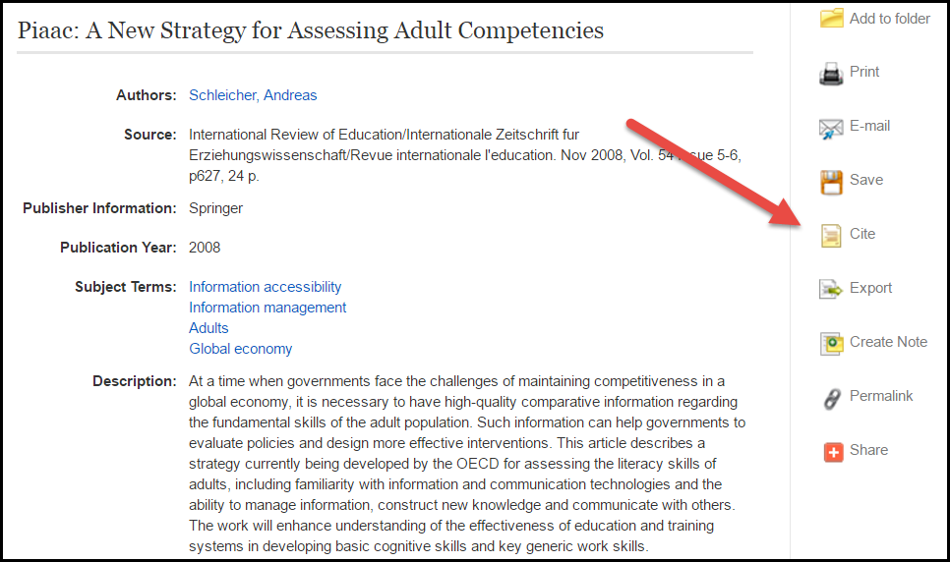

It is tempting to use this feature as a short cut. Please read the fine print: Review the instructions at EBSCO Support Site and make any necessary corrections before using. Pay special attention to personal names, capitalization, and dates. Always consult your library resources for the exact formatting and punctuation guidelines.

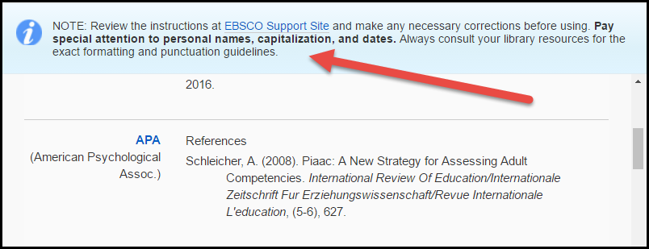

However, some students do not read the note. As a matter of fact the library references are formatted by an automated system, and unfortunately the computer is blind to errors. Can you see something wrong in the following reference?

Schleicher, A. (2008). Piaac: A New Strategy for Assessing Adult Competencies. International Review Of Education/Internationale Zeitschrift Fur Erziehungswissenschaft/Revue Internationale L'education, (5-6), 627.

There are at least six mistakes:

- PIAAC is an acryom and therefore “Piaac” should be written as “PIAAC”
- There is no need to capitalize the first letter of each word for the article title.
- There is no need to capitalize the first letter of a preposition (e.g. of, for, in…etc.)
- When citing a foreign journal, you need to transliterate or translate the article title into English, but not the journal title.
- If the page numbers are consecutive across all the issues in the same volume, you need to include the volume number only, but not the issue number.
- You need to include the first and the last pages of the article.

Hence, the correct format should be as follows:

Schleicher, A. (2008). PIAAC: A new strategy for assessing adult competencies. International Review of Education/Internationale, 54, 627-650.

